Specification for

**Emergency Ventilators**

Need to establish fleet of 10,000+ ventilators in 6 weeks

NOTE

The concept demonstrated in this document is based on professional experiences in the design and development of life-support ventilators. The concept has not been prototype tested and will need validating. Many details are yet incomplete in the current draft. The concept is open source – free to use, evolve or transfer in parts into other designs.

Issue/change record

|  |  |  |  |
| --- | --- | --- | --- |
| Issue | Date | Author | Reason of issue/summary |
| 0.A | 22/03/2020 | F. Jensen | DRAFT, released for ongoing development |
| 0.B | 28/03/2020 | F. Jensen | DRAFT, revised Monitor schematic. Defined pressure waveform and alarm sounds. Added humidification comment |
|  |  |  |  |
|  |  |  |  |
|  |  |  |  |
|  |  |  |  |

Contents

Introduction 3

1 Design specification 3

1.1 Device application context 3

1.2 System level design 4

1.3 Ventilator requirements specification 5

1.4 Ventilator functional specification 7

1.4.1 User interface 7

1.4.2 Schematic diagram 10

1.4.3 Ventilator operation flow chart 11

1.4.4 Pressure waveform specification 12

1.4.5 Alarm signals 13

1.4.6 Components 14

1.4.7 Electronic design 15

1.4.8 Firmware flow – Level 1 17

1.4.9 Firmware flow – Level 2 17

1.4.10 Labelling 18

1.4.11 Clinical procedure 18

2 Design validation 19

2.1 Risk management plan 19

2.1.1 Risk acceptance criteria 20

2.1.2 Hazards analysis 22

2.1.3 Risk evaluation 25

2.2 Clinical evaluation 25

2.3 Usability evaluation 26

2.4 Accelerated life-cycle and environmental testing 26

2.5 Biocompatibility evaluation 26

3 Supporting concepts 26

3.1 Low tech gas blender 26

3.2 Exhaled gas (heat) disinfection device 27

3.3 Humidification 27

# Introduction

This document contains the full concept design (section 1) and validation (section 2) information for a medical emergency ventilator. In combining what are usually separated activities into one document, enables the information be transmitted and updated at multiple locations, within losing their interlinked context.

The design is intended for the 75% of intensive care beds that are yet to be established in makeshift facilities. The document also contains two further concept ideas (section 3) that expand on the device. These are optional and can be disregarded if/when deselected.

# Design specification

## Device application context

The COVID-19 coronavirus pandemic is in March 2020 an evolving health emergency across the world. The UK Government, as an example, has in the region of 8,000 respiratory life support ventilators, including old stock and special devices (e.g. neonatal). This number is insufficient in meeting the pending crisis demand. The UK urgently requires 20,000 additional ventilators in the next 6 weeks. Practically every country in the northern hemisphere has a similar situation, meaning that there is very little scope for inter-nations support. Each country must largely find its solutions within its own nation.

Obtaining 20,000 ventilators in 6 weeks is just the basis for meeting the needs. The hospitals system says it can double the number of intensive care unit (ICU) beds, which in the UK means that pre-existing hospitals have facility capacity to expand its ventilator fleet by about 5,000. The remaining 15,000 ventilators will be operated in facilities yet to be established and by non-expert healthcare personnel yet to be trained in respiratory therapy. One branch of the UK Government has allocated just 30 minutes to each staff for ventilator training. The situation demands a shortcut approach.

Once the healthcare system is forced to turn warehouses into makeshift intensive care wards, as the images seen from Italy, then each ‘ward’ will feature the following characteristics:

* Hundreds of patients, tightly organised.
* Rudimentary infrastructure – probably mobile compressors and restricted use oxygen bottles.
* Healthcare staff with below average respiratory care skills, and very tired/overworked.

This is not a realistic environment for an advanced skills and infrastructure demanding ICU ventilator. It is also not an environment for a single limb homecare ventilator, which exhausts contaminants into the ambient environment and places the healthcare personnel at significant risk from cross-contamination. Off-course, we have reached emergency conditions and compromises must be made.

Health services across the world are procuring ventilators. It is observed that many procurement specifications have requested Volume Control ventilation. Real-time breath volume measurement technology is relatively complex to implement (compared to pressure measurement). It demands components and sensors with very fine manufacturing tolerances, available from a limited number of global suppliers. The blending of air and oxygen, into a medical gas, is another feature that adds to a component count that is in short supply or currently cannot easily be shipped across the world.

It must also be remembered that more than 75% of the emergency ventilators will be operated by non-expert personnel, who will find the complexity of Volume Control unmanageable – both therapeutically and technically. Simpler Pressure Control ventilators of the past (as the one I monitored as an Army nurse in the 1980’s) have delivered, and are still delivering, a valuable level of therapy – without Volume Control. Pressure Control ventilation can offer a better match for the conditions in the makeshift ward.

It is also observed that some health services are specifying that emergency ventilators should display both the control settings and the monitored values of these settings. For example, the emergency ventilator should display both the set PEEP (Peak End Expiratory Pressure) and the actually measured PEEP. Again, it must be remembered that 75% of the emergency ventilators will be operated by non-expert personnel. Respiratory ventilation is an output-based therapy. It is meaningless to treat a patient by the input parameters. These are the mere starting point, because a set of input parameters will produce different results for different patients, and they might well produce different results for the same patient at different times (as the diseased lung changes).

Displaying both the set and monitored input parameters will add an unnecessary (valueless) layer of complexity for the non-expert operator. The make-shift ward demands simplification – not complication. The simplified ventilator should instead just show the essential control settings, but monitor in the background that these are achieved – and alarm if they are not. If the ventilator control settings are shown and the monitor does not alarm, then it evidences that the settings are achieved (within tolerances).

It is well documented (although the profession does not always like to admit it) that putting a low-tech ventilator in the hands of a highly skilled respiratory therapist, can achieve a better patient outcome than putting a high-tech ventilator in the hands of a lesser skilled respiratory therapist. Patient outcomes depends more on the clinical skills and procedures, than on the technology. The simplification and lacking functionality have potential for slightly decreasing the clinical efficacy; but this is easily outweighed by the benefits from having a device that the lesser skilled clinicians is comfortable operating.

## System level design

The system level here illustrates a 10-bed ward. This configuration is scalable to many more beds, in extended or parallel arrangements. The ventilators stand on bedside tables. The ventilators receive pre-blended gas, from one of optional supply lines. This arrangement significantly simplifies the ventilator design.

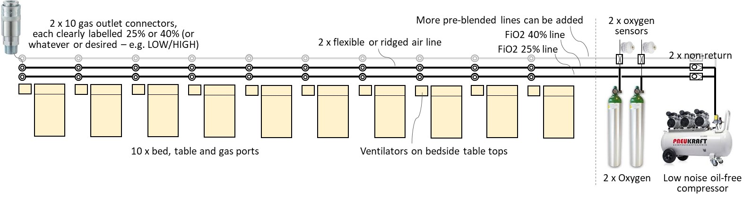

The example here shows 2 parallel gas lines, supplying pre-blended 25% and 40% FiO2 (finally inspired oxygen concentration) respectively. The FiO2 settings can be changed to whatever clinicians prescribe. For example, the pair of lines supplying a group of 10 severely compromised patients might be set differently (say, to 30% and 50%) to a different pair of lines supplying a group of lesser compromised patients (say, 21% and 30%). The 2 lines could also be extended to 3 or 4, in areas where the needs demand it.

The FiO2 concentration in the supply lines is adjusted by regulating the oxygen supply pressure from the bottles. The concentration is monitored using simple oxygen cell technology. The monitor will signal if the FiO2 level drifts, say when several patients are switched to the alternative line. This will require a technician attending to the lines and adjusting the oxygen bottle regulator, until the target FiO2 is met (+/-3% v/v).

## Ventilator requirements specification

The design has the following characteristics:

* Interfaces with intubated, unconscious and semi-conscious, patients; and interfaces with pressure ventilation masks on conscious patients.
* 22mm patient circuit, using commonly available components (no bespoke circuit component). The ventilator presents 22mm ‘male’ fresh gas port and 22mm ‘female’ on the exhalation valve. Single-use is preferable, with minimal reusable parts – e.g. a disposable single-use exhalation value that is supplied pre-assembled onto the patient circuit is preferred.
* Exhalation exhaust port is standard 22mm connector, enabling bacterial filter or gas scavenging to reduce the risk of cross-contamination (see Section 3 for optional disinfector concept).
* HME (Heat Moisture Exchange) device is used at the patient interface.
  + Optionally, the ICU can elect to use a medical gas humidifier (heat or ultrasound actuated), if one is available and preferred; but this is not the default low tech, low skill design solution (mal-adjusted humidifiers in the hands of non-experts can ‘drown’ a patient).
* Directional non-return valves at each end of the patient circuit, to allow ambient air supply for the patient’s spontaneous breathing under gas supply or ventilator failure conditions.
* Pressure Controlled SIMV (Synchronised Intermittent Mandatory Ventilation) mode of ventilation only. No need to select and switch between alternative modes. SIMV behaves as PSV (Pressure Support Ventilation) when the patient makes efforts, and it behaves as CMV (Continuous Mandatory Ventilation) if the patient does not make any efforts. When used with a mask on a consciously breathing patient, the SIMV behaves as Synchronised BiPAP. Switching the PIP cycle off (or setting it equal to PEEP) makes SIMV behave as CPAP (whether the patient is intubated or has a mask interface).
* Breath detection by pressure change algorithm (not flow sensor or nerve activity).
* Maintains steady PEEP level and PIP plateau under mask leak conditions.
* PEEP/EP (Peak End Expiration Pressure), between 4 mbar and 20 mbar, adjustable in 1 mbar steps (1 mbar = 1.02 cmH2O and the 2 units can be considered practically equal).
* PIP/IP (Peak Inspiration Pressure), between 4 mbar to 35 mbar, adjustable in 1 mbar steps.
* Patient circuit pressure is limited to maximum 40 mbar under ventilator failure conditions. Reliable failsafe prevents any single failure mode from resulting in compressed supply gas reaching the patient.
* BPM (Breath Per Minute) rate 10 to 30, in steps of 1. This can be increased to 40 is desired.
* I:E ratio (Inspiratory-Expiratory) fixed 1:2.
* Does not incorporate a gas blender. The makeshift ward should instead have 2 or more supply lines with pre-blended gas (say, FiO2 25% and 40%), which the clinicians can elect to plug into. The process for switching from one supply line to another during patient ventilation, will require that a lung recruitment manoeuvre is performed (e.g. 2 seconds manual breath) immediately after switching – to assure optimum CO2 elimination.
  + Optionally, if a blender is required, then Section 3 describes a low tech mechanical (non-electrical) solution, which can be added. This could be added to the outside (or inside) of the ventilator, for those special cases that needs an FiO2 21% to 100% setting that differs to the pre-blended options.
* Supply gas pressure 2 to 7 bar (pressure regulator must ideally withstand 7 bars, but compromise to 5 bar is possible where the compressor output is assured to max 5 bar).
* Industry standard gas connectors. Uses a single gas supply to ventilator, with the hose continuously connected at the ventilator end. Air-Oxygen differentiation is therefore not required. Any industry standard quick release pneumatic connector can be used, but it must be the same consistent standard across the care ward.
* 110V to 240V, 50Hz to 60Hz mains power. Integrated 45 minutes backup battery power (when using 2.1Ahr battery).
* Indicator lights visible at more than 3 metres distance:
  + Red flashing light when an alarm condition exists (this could be made tricolour).
  + Green light flashes once for 0.5s when a breath is detected.
* Audible alarm, with IEC60601 standard priority ‘melody’ (high, medium, low).
* Alarms messages in LCD displays for:
  + Monitor error (high priority, detected and reported by controller sub unit).
  + Controller error (high priority, detected and reported by monitor sub unit).
  + Gas supply failure (high priority).
  + Battery low (high priority).
  + Patient circuit disconnect (high priority).
  + Patient circuit overpressure shut down (high priority).
  + Set PEEP not achieved +/- 2mbar (medium priority).
  + Set PIP not achieved +/- 3 mbar (medium priority).
  + PIP rise time not achieved (medium priority).
  + Expiration decay time too long (medium priority).
  + Mains power loss (low priority, switch to battery power).
  + Patient circuit leak (information only message, flashing up for 1 sec every 3 sec).
* Monitor display:
  + Trigger Rate – as the percentage of delivered breaths that were initiated by the patient. This is a measure of patient efforts and consciousness (progress or deterioration).
  + Tdi, the PIP rise time – indicator of lung compliance, but also if gas supply pressure fails.
  + Tde, expiration wave decay time – indicator of the bacterial filter or patient circuit being soiled (excessively resistive) and need replacing. Where a small resistance is added to the exhaust (i.e. bacteria filter) the Tde can also help indicate lung obstruction (fluids, puss).

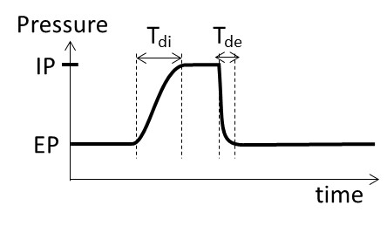

* Maximised use of off-the-shelf components that are readily available in a national supply chain.
* The type of components all have prior use in respiratory ventilators and can be assumed to have an acceptable RF and EM compatibility profile. The emergency situation does not afford time for extensive EMC testing.
* Tolerant to alternative components use – e.g. can use 1.6mm orifice solenoid valve from one brand or 2.4mm orifice solenoid valve from another brand – including a mix of different sizes. Simply adjust the pressure regulator to suit (to achieve the standard PIP rise time).
* All components in the gas pathway are oxygen resistant and free from obnoxious/infectious materials. For example, the regulator and solenoid valves do not have any oil residues from their manufacturing process. Pre-cleaning might be an option.
* Enclosure:
  + Metal construction.
  + Bottom vent holes, as required to evacuate any oxygen leak (heavier than air), to prevent a combustion hazard.
  + Bottom and downward-facing louvre vents, so that water poured on top of device will not ingress to the internal electrical components.
  + Surfaces are smooth/polished and free from crevasse that might harbour germs, for easy cleaning.
* Desktop mounted, with 4 rubber feet.
* Design to be developed and validated to ‘acceptable’ standards in 1 week.
* Design to be produced and tested at a high rate by a low skilled workforce, supervised by someone skilled in the medical device precautionary processes. Each ventilator must be approved/signed off by an individual that is competent in assessing the impact of ventilator performance on a patient.
* User instructions in a detailed training and service manual, and an A4 laminated quick guide.
* Packaging for containment, preservation and cleanliness during transport t.b.d.
* Combination devices required to monitor ventilation output:
  + Portable TcCO2 or EtCO2 device, to monitor CO2 elimination (measure of ventilation efficiency).
  + Portable SpO2 device, to monitor blood oxygen saturation.

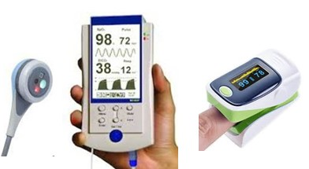

## Ventilator functional specification

This section describes how the requirements specification is met.

### User interface

The user interface is very simplified (and somewhat industrial looking). The top half of the facia is the monitoring interface. The bottom half is the controlling interface.

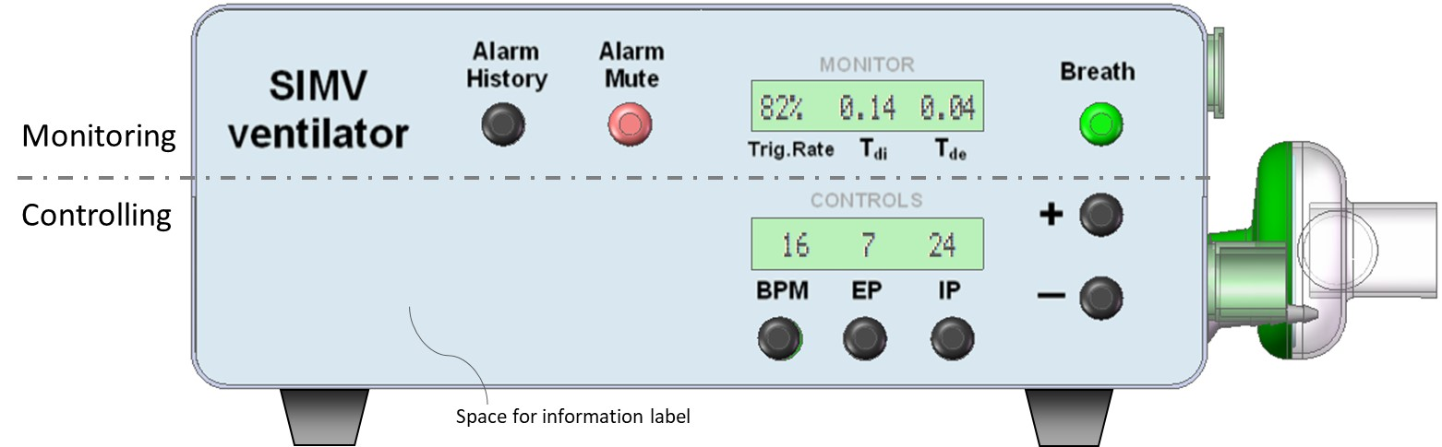

The process for adjusting a control paraments:

1. Press parameter control button.
2. Observe that the parameters value starts flashing (will time out after 5 sec inactivity).
3. Adjust the flashing parameter value using the +/- buttons.
4. Press parameter control button again to confirm the new setting.

The ‘Breath’ button has an integral green light. This flashes for 0.5s every time a breath is detected. Pressing the green button delivers a manual breath. This is used to re-recruit the lung following a procedure that temporarily disconnected the patient from the ventilator, such as during suctioning or while changing the FiO2 level.

The ‘Alarm Mute’ button has an integral red light, which flashes under an alarm condition. Pressing the button will cancel the alarm event and suspend further alarms for 120 seconds.

The ‘Alarm History’ cycles through the last 10 alarm messages.

Alarm messages appear in the monitor (top) LCD display, where they overwrite the monitored parameters from 2.5 seconds every 3 seconds – i.e. the monitored values flashes up for 0.5 seconds every 3 seconds while an alarm message is displayed.

The alarm message ‘Monitor Fail’ is detected by the controller and is displayed in the lower LCD.

Hospital staff commonly write information or place labels on their medical equipment, such as giving the device an identifiable name or number, or placing a reminder label. The facia is given a space for this. Below is an example reminder label that may be useful for certain personnel – without crowding the facia and detract from its simplicity.



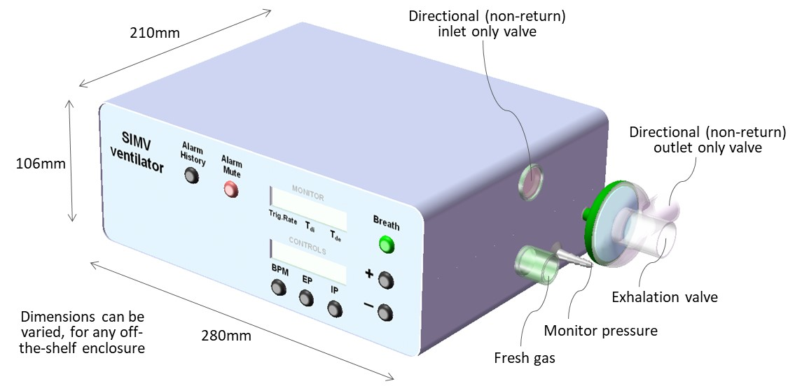

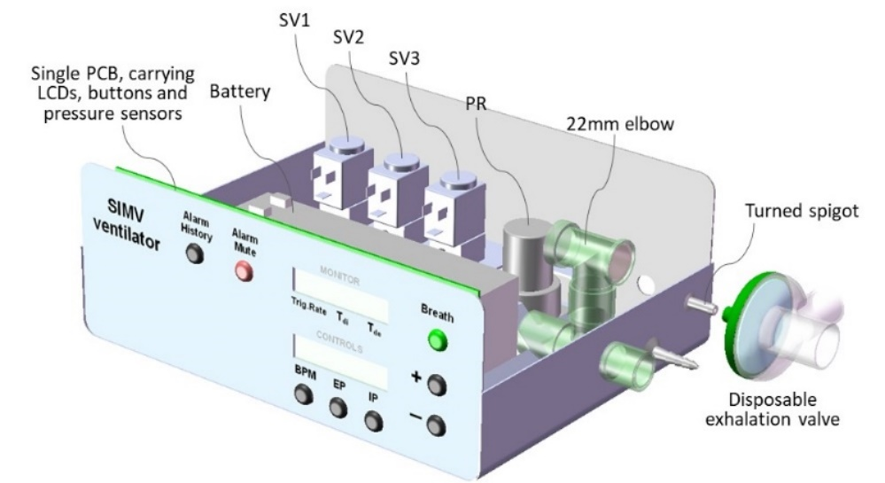

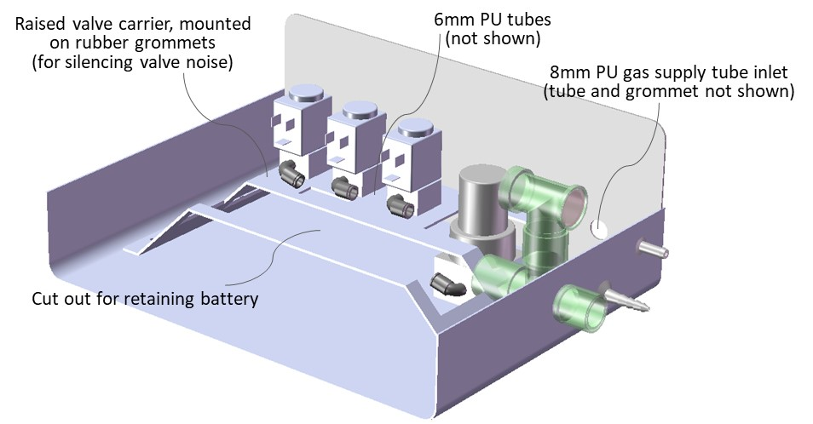

### Schematic diagram

The Monitor and Controller operate independently, in parallel, observing each other (watchdogs). This assures the detection and alarming on any single failure mode. Both the controller and the monitor are capable of detecting an excess pressure (>40 mbar) and each can shut down the supply gas. This duality safeguards that compressed gas does not reach the patient circuit. All valves are NC (normally closed) types and will default to shutting off gas supply in case of total (battery) power failure.

The Controller operates its own user interface, for adjusting the parameters (BPM, EP and IP). The Controller reports its 3 parameters values every 50mS across an I2C serial interface with the Monitor. The Controller also reports when a valid change is made via the user interface. If the Monitor does not acknowledge receipt, then the Controller will instigate an alarm.

If the Controller reported ventilator paraments changes, without a prior valid user change, then it would indicate the Controller memory has corrupted. The Monitor will then alarm and can shut down gas supply if hazardous conditions occur.

The Monitor also calculates the triggered breath rate (patient effort) and the wave rise/decay times (Tdi and Tde, which indicates lung/system status). It will alarm if these deviate from tolerances.

On shut-down, the patient can breathe ambient air through the 2 directional NR valves.

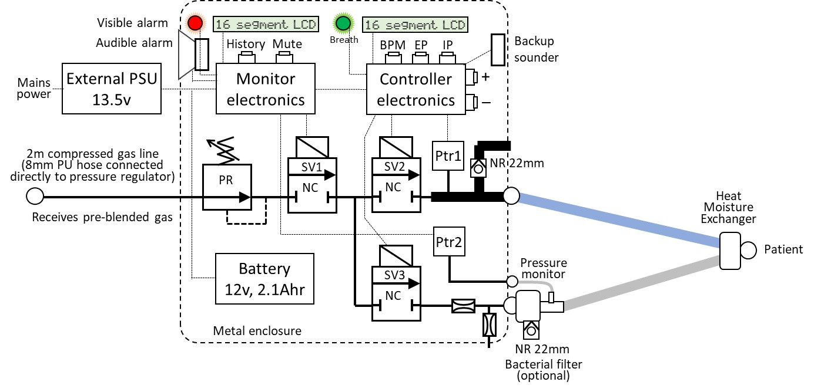

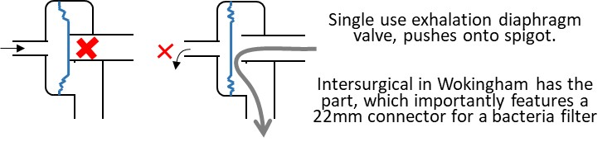

### Ventilator operation flow chart

The Controller cycles the pressure wave in accordance with the set parameters (BPM, EP and IP). The inspiration cycle is instigated on breath detection, or if the mandatory cycle time is reached.

‘Open SV3’ has the effect of closing the exhalation valve – i.e. it should be read as ‘close exhalation valve’.

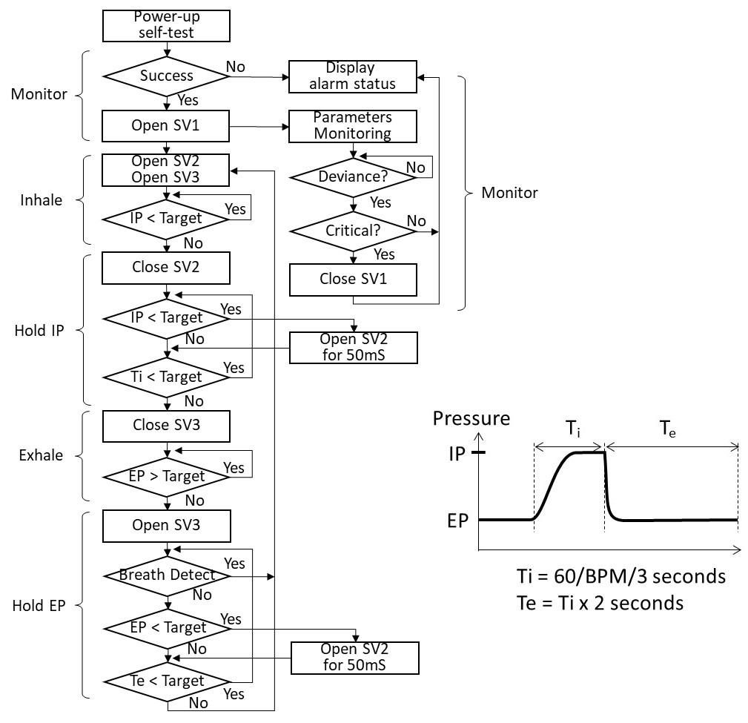

The steps ‘IP < Target’ and ‘EP > Target’ are likely to result is a small overshoot if implemented in their simplest form, due to the solenoid valve inertia/response time. The step will likely have some sub-steps to compensate for this, for example:

1. One approach: Once the ventilator user sets a new Target the initial breath cycle will use ‘IP < Target x 95%’. If this first breath undershoots, then the next cycle can be increased to ‘IP < Target x 96%). Keep incrementing until the intended IP is met and then freeze this setting. Do the same in reverse for reaching EP. The first cycle might use ‘EP > Target x 105%’ and then decrement this correction factor. Freeze the correction factor once the intended EP is reached. It could take 2 or 3 breaths for the ventilator to settle the IP and EP after a setting is changed.
2. Another approach, is to use testing and understanding of the overshoot and then build a fixed correction value into the software – i.e. the final compensation is applied to the very first breath cycle. A small variance can creep in if the IP rise time (Tdi) or EP decay time (Tde) changes/drifts, or if different solenoid orifice sizes are introduced. Such a small variance might be within tolerance and considered accurate enough. If not, the solution a) above is better at responding to the dynamics in the patient and circuit conditions.

The steps ‘Open SV2 for 50mS’ tops-up the patient circuit pressure, to compensate for leak in nSIMV/SyncBiPAP/CPAP with mask. In mask mode, this is will create a harmless ripple on the pressure plateaus. In fact, in HFOV and Bubble CPAP ventilation in infants, such type of pressure ‘vibration’ is reported to improve alveolar gas diffusion (makes ventilation more efficient).

The top-ups will not normally happen with an intubated patient, unless the circuit is incorrectly connected/faulty. The ventilator would indicate that top-ups are happening – hence, indicating a potential patient circuit problem.

In mask ventilation, the breath detection algorithm needs to discriminate between the patient breath effort and a top-up ‘ripple’. The former manifests as a small pressure drop, while the latter manifests as a small pressure rise – i.e. they are different and detectable, until they occasionally collide. Possibly, under large leak conditions, the breath detection sensitivity will have to be lowered, to prevent false triggers. Fortunately, mask ventilation is used primarily with strong breathing patients.

When making EP and IP the same value (showing IP as ‘OFF’), the ventilator is effectively in CPAP more and the IP steps can be by-passed. When the then patient breathes in, the pressure in the circuit reduces and SV2 will compensate by pulsing in fresh gas. When the patient subsequently exhales, the pressure in the circuit increases and valve SV3 will deactivate to exhaust the exhaled gas. This routine secures minimal gas/oxygen consumption in CPAP and BiPAP modes (contrary to conventional devices, which maintain about 15L/min continuous flow).

### Pressure waveform specification

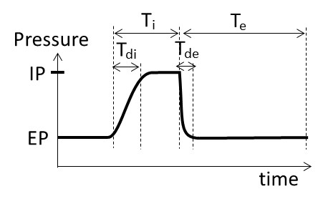

Ti (inspiratory time) varies between 0.7s (at 30 BPM) and 2s (at 10 BPM). Te (expiratory time) is 2 times Ti, according to the fixed 1:2 I:E ratio.

The ideal Tdi (inpspiratory pressure rise time) is about 0.2s, or 1/3 of the Ti, when ventilating a patient lung. Beware if using a test lung with different compliance (e.g. a 5L plastic bottle) the Tdi will differ.

Tde should be as short as practically possible. The actual Tde depends on the lungs natural elasticity and resistance in the breathing circuit. As long as it looks reasonable sharp then the CO2 washout will happen.

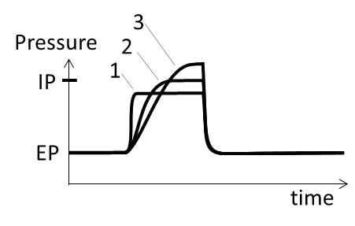

The rationale for Tdi is illustrated by the 3 waveform examples above. Each the 3 waves deliver about the same amount of ‘work’ and fill the lung with an equivalent volume of gas.

#1 uses the least pressure (which is good), but the abrupt rise is faster than the lung can comply. This risks putting shear stress on the lung tissue.

#3 produces a gentler rise (which is good), but it requires a higher plateau (which is bad) because the lung tissue is sensitive to pressure (barotrauma).

#2 is the best compromise. The plateau should be about 2/3 of the Ti time – meaning Tdi should be no more than 1/3 of the rise time. With the fastest Ti being 0.67s, the best fixed Tdi = 0.2s.

A 5L plastic bottle test lung tends to be less compliant and fills more straightforwardly (compared to the intricate lung). Development testing should probably focus on Tdi = 0.15s. Tdi is adjusted by regulator PR, or by changing the orifice size in SV2.

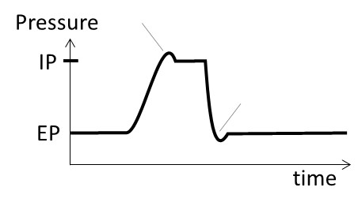

Small over-/under-shoot spikes are tolerated, but undesirable. An IP overshoot larger than 3 mbar is not tolerated. There are actually special modes of ventilation that has a lower IP plateau combined with a larger overshoot, and there are modes that deliberately undershoot the initial EP plateau (to help CO2 washout). However, these are specialist modes and should be default in an emergency ventilator.

Lastly, it is one thing to re-produce the pressure waveform. It must be simultaneously assured that inhaled gas comes from the fresh supply side and that exhaled gas is entirely directed into the exhaust path. The patient must not rebreathe the same gas, which would become increasingly oxygen depleted and CO2 enriched (results in suffocation). Many ventilators have a continuous flush flow through the circuit; but this is omitted in this design, to preserve oxygen (in short supply).

### Alarm signals

The signals are specified by an international standard.

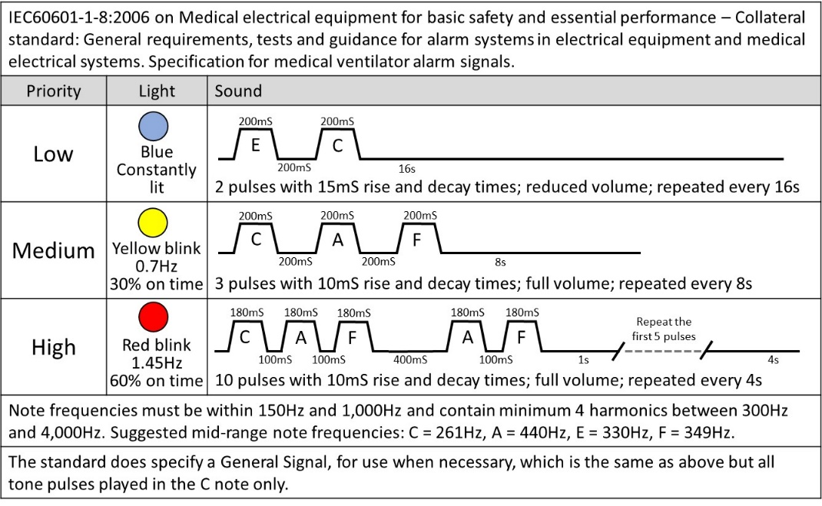

It is acceptable for an emergency ventilator to deviate from the standard. The alarm sounder in this design conforms to the standard pulse lengths, but it will be played in a single tone – aligning to the ‘general’ tone specified in the standard (although not the tone rise/decay) – i.e. it plays the correct melody, but in just one note. This simplifies construction and the development time.

It is proposed to use a single colour alarm light, but to pulse it in compliance with the standard.

### Components

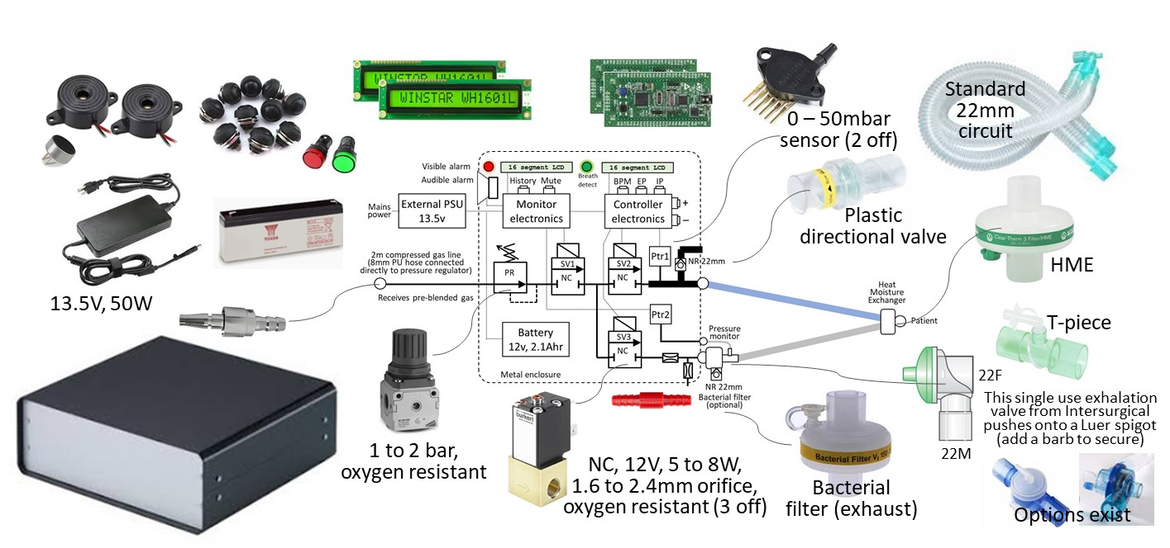

All components are available off-the-shelf at most national levels. **Total components costs for the ventilator are approximately £350 (GBP), or Eu380 or US$410. Each patient circuit has a component cost of £12 (GBP), at trade prices.**

Components are selected for having known acceptable electro-magnetic characteristics in other applications (to enable omission of time-consuming EMC qualifications).

The design is highly tolerant to alternative brands and specification variances. For example:

* The pressure regulator can be any brand that is oxygen resistant and is adjustable between 1 and 2 bar (15 and 30psi), while being stable. Possibly a relieving type is most stable, but a non-relieving can be acceptable. The low cost (£14) type shown above is fine. Small and cheap (£8) regulators (the type measuring less than 15mm across) tend to be less stable and are likely unsuitable.
* The solenoid valves simply need to reliably open and close in 20mS or less. There is no need for a fast 3mS response. The valves must of course have oxygen resistant seats and seals. The orifice size can be between 1.6mm and 2.4mm (needs validating, increase if necessary), but should preferably be the same across all 3 valves. If the sizes must vary, then ensure that SV1 has the largest orifice and SV3 has the smallest orifice. SV2 can then be anything in between. Set up by ventilating into 5L plastic bottle (representing a test lung). Adjust the pressure regulator until the PIP rise time (Tdi) is 0.12 second (this will become slightly longer into a real lung, which is more compliant than a plastic bottle). This adjustment of the pressure in effect compensates for the orifice sizes. Note, clinical evaluation might find that a slower rise time is preferred. Then simply adjust the pressure regulator to the different desired level. Mount the valves on noise reducing rubber grommets.
* The power supply and battery must be 13.5v and 12v respectively, but any brand and shape are accepted. The specified 2.1Ahr battery can be changed to a different size, but beware that the 45 min battery backup time will be affected.

All patient circuit parts are readily available from a number of medical plastics suppliers across the world. In the UK and Norther Ireland, these would include Intersurgical, Flexicare, Armstrong and/or Europlaz. There are many others around the world.

The 22mm patient connector ports must conform to the international standard (summarised here).

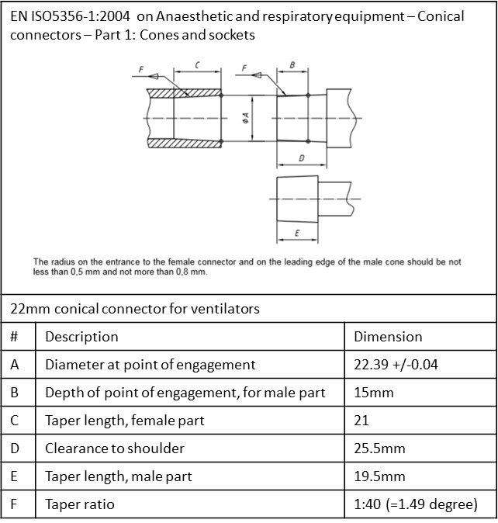

### Electronic design

The following diagrams (next page) suggests using a Microchip PIC controller. Any alternative microcontrollers with the appropriate number of General Purpose in/out ports and an ADC port can be used.

The Monitor instigates a serial I2C data exchange with the Controller every 50mS. It receives the set Control parameters in return. The Monitor and Controller electronics are electrically separated by at least a 4mm gap. A failure in one unit will not electrically influence the other over the I2C data lines.

Both the Monitor and the Controller (ADC) measure the pressure sensors analogue signal every 2mS.

When the monitor alarms it listens (microphone) for the speaker sound to appear. In case of a no-sound failure, the Monitor requests the Controller to sound the backup sounder.

The Controller will sound the backup sounder and display ‘Monitor Error’ if the Monitor does not poll it for 100mS.

The SLA (sealed lead acid) battery is continually float charging at 13.5V. This avoids a battery management circuitry and simplifies the design.

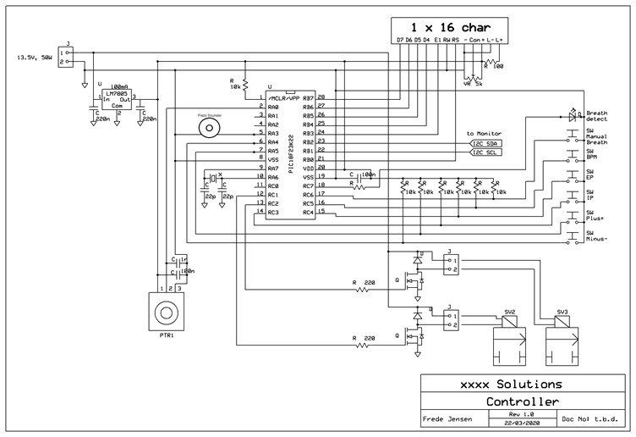

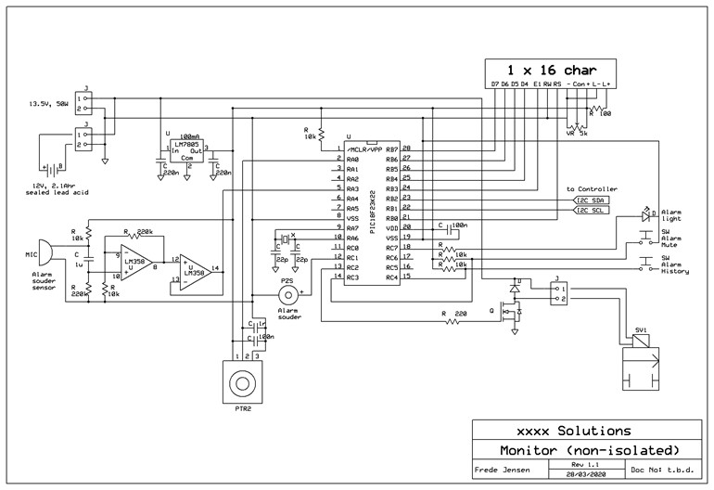

### Firmware flow – Level 1

To be developed. The operational flow chart shown in section 1.4.3 is not complex to implement, for a skilled software/firmware developer. Although the development is an emergency, the fundamental principles of international standard IEC 62304 on medical device software life-cycle processes should be observed.

### Firmware flow – Level 2

To be developed. It is assumed that all standard medical software precautionary routines are used, such as 3 best of 5 tests for values stored in EEPROM cells (i.e. 1 value is stored 5 times, of which a test verifies that at least 3 are the same, before being applied).

#### Breath detection algorithm

Pressure wave breath detection uses a commonly known algorithm, which is well tested in existing marketed medical ventilators. It involves filtering/integrating the real-time patient circuit pressure into two mean values in the Controller: one is fast with a 50mS time-constant and the other is slow with a 2000mS time-constant. When the patient breathes in the circuit pressure will momentarily drop. The fast filter/integrator output will drop faster, and ‘cross’ below the slow filter output. An offset is added to the fast filter value. This offset determines the breath detection sensitivity. If the offset is too small then the algorithm risks creating false triggers (from underlying sensor/measurement noises). If the offset is too large then the algorithm risks missing a weak patient effort and the detection is delayed (less synchronized and supportive to the patient). The Controller should report the detection rate to the Monitor, for comparison and display (and alarm if they mismatch).

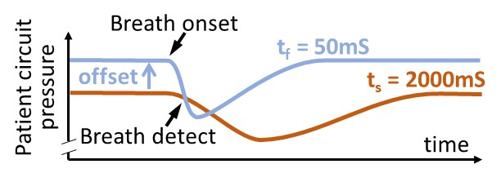

Its pseudo-code is included here for information:

BEGIN {ISR}

Save context: working, status, and program counter registers

IF interrupt = I2C buffer full

Call I2C_HANDLE

ENDIF

Pressure = ADC port value

IF pressure > 40 mbar

Call SHUTDOWN

ENDIF

Pressure_fast = Mean for last 25 Pressure values

Pressure_slow = Mean for last 1000 Pressure values

Offset = 0.3 mbar // Declare as a constant

IF (Pressure_fast + Offset) < Pressure_slow

Breath_detect = TRUE

ENDIF

[…] // Add other routines here

Restore context: working, status, and program counter registers

Clear interrupt flag

RETURN from interrupt

END {ISR}

BEGIN {MAIN}

Call CONFIG_MPU_REG

Call INITIALIZE_VARIABLES

Call INITIALISE_ISR // Set to ISR call to every 2mS

WHILE 0

Call USER_INTERFACE

[…] // Add other routines here

ENDWHILE

END {MAIN}

Routines for calculating the P_short and P_long mean values:

If using floating points math (called every 2mS):

[…]

Pressure = ADC port value

temp = P_fast/25

P_fast = P_fast – temp + (Pressure/25)

temp = P_slow/1000

P_slow = P_slow – temp + (Pressure/1000)

[…]

If using fixed points math (called every 2mS):

[…]

Pressure = ADC port value

Add Pressure to P_fast_buffer[25] // Overwrite the buffer tail, move tail pointer

P_fast = (Sum of P_fast_buffer[25]) / 25

Increment ISR_call_count

IF ISR_call_count = 40 // Only use 1 in 40 measured values

Add Pressure to P_slow_buffer[25] // Overwrite the buffer tail, move tail pointer

P_slow = (Sum of P_slow_buffer[25]) / 25

ISR_call_count = 0

ENDIF

[…]

#### Tdi and Tde detection and measurement

Similar to breath detection, maintain 2 filters/integrator in the Monitor: one is fast with a 50mS time-constant and the other is slow with a 300mS time-constant. When P_fast = P_slow then we are at a pressure plateau level. When P_fast > P_slow then we are in a Tdi phase. When P_fast < P_slow then we are in a Tde phase. Start and stop time counters at each phase change. You would average the values over the last 10 seconds of operation. Disregard any rogue values (appears more the +/-10% of the average). This will still detect a natural, gradual drift.

### Labelling

The back of the device must carry the information stipulated in regulatory requirements for ventilators. It is assumed that the regulatory qualification will be short-cut and that CE-marking might not be completed. Residual risks are described in the user manual and service manual.

### Clinical procedure

The ventilator is designed for simplified mass-ventilation, with an operating principle that supports a deskilled (skill-divided) clinical process. This process frees-up the most skilled clinicians from hands on activities, in part to enable them focusing on a maximum number of patients, and in part to reduce their exposure to patient contaminants. In crude terms, it is easier to replace a lower skilled assistant than it is to replace a doctor.

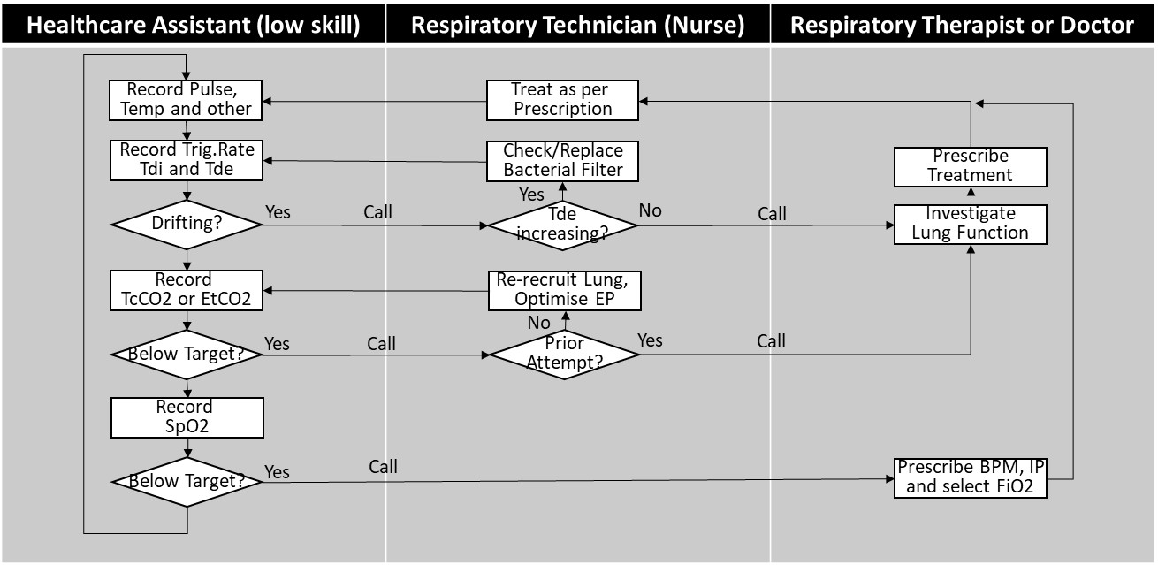

A drift in the Trigger Rate would indicate a change in the patient’s overall condition. It can be seen as a measure of stabilisation and recovery – or an indication that a rescue therapy is required.

A drift in the Tdi (IP rise time) and/or Tde (expiration wave decay time) indicates that the lung condition is changing. A shortening in Tdi would indicate a worsening of the lung condition, such as respiratory distress or a build-up of fluid or puss (which would need clearing out by a suctioning procedure). They could also indicate a problem in the patient circuit or the exhaust bacterial filter.

Selecting a different FiO2 level requires that the ventilator is temporarily disconnected from one supply and connected to another (in a matter of seconds). The Respiratory Technician should subsequently press and hold the ‘Manual Breath’ button once for 2 seconds, to re-recruit the lung.

‘Optimise EP’ is done by increasing the EP by 4 or 5 mbar. Then reduce EP by 1 mbar and observe the resulting TcCO2 or EtCO2 value for 15 – 20 seconds (until settled). Repeat and observe how the CO2 elimination improves with each step, until it suddenly worsens. Return EP to the vale that produced the best CO2 elimination. Then press and hold the ‘Manual Breath’ button once for 2 seconds, to ensure that the lung is fully recruited. A simple procedural manoeuvre.

# Design validation

## Risk management plan

1. Define the risks acceptance criteria.
2. Determine the potential sources of harm.
3. Eliminate or reduce the risks as far as possible (inherently safe design and construction). Take adequate protective measures, including alarms if necessary, in relation to risks that cannot be eliminated.
4. Evaluate all residual risks against the acceptance criteria.
5. Effectively inform users of any residual risks from any shortcomings of the protective measures adopted.
6. Maintain traceability. Receive, record and handle incidents and near incidents. Receive feedback on general market acceptance of risks. Review (go back to point 1) when confidence in risk acceptance reduces.

### Risk acceptance criteria

Risk acceptability is based on a rating of the probability of occurrence of harm and severity of the consequence of that harm. The rating may be weighed or influenced by recognized standards and/or perception factors – in the context of the particular markets and needs.

Table 1: Definition of probability of occurrence of harm

|  |  |
| --- | --- |
| Frequent | 1 occurrence in every 5 device operating days, or every 1 patient treatment sessions |
| Probable | 1 occurrence in every 50 device operating days, or every 12 patient treatment sessions |
| Occasional | 1 occurrence in every 500 device operating days, or every 125 patient treatment sessions |
| Remote | 1 occurrence in every 5,000 device operating days, or every 1,250 patient treatment sessions |
| Improbable | 1 occurrence in every 50,000 device operating days, or every 12,500 patient treatment sessions |
| Almost impossible | 1 occurrence in every 500,000 device operating days, or every 125,000 patient treatment sessions |
| Assumptions and context:   * Average patient treatment session is 5 days * Average number of sessions per year per device is 60 patients * Number of ventilator operating days per year per device is 160 days * Estimated market life of device design is 15 year, of which 14 years is in non-use storage. * Total number of devices in the market is 10,000 units * Total number of patients exposed to all devices over the market life of the device design is 600,000 patients, during emergency situations over the 15 years device life (used 1 year). * Total number of device operating days over the market life of the device design is 3 million days, over 10 years when the device is only used intermittently for a combined 1 year. * Ventilation therapy involves significant variability in clinical application, skills and judgement, which has a bearing on the quality of patient outcomes with any given device. | |

Table 2: Definitions of consequences of harm

|  |  |
| --- | --- |
| Catastrophic | Potential for resulting in death or multiple deaths |
| Critical | Potential for resulting in permanent non-trivial impairment or life-threatening injury |
| Serious | Potential for injury or impairment requiring additional professional medical intervention. |
| Minor | Potential for temporary injury or impairment not requiring additional professional medical intervention. |
| Negligible | Results in inconvenience or temporary discomfort |
| Persons to be considered as possibly affected are patients, clinical personnel (users of the device), hospital technical and cleaning personnel, device manufacturer’s service personnel, relatives and any other visitors who could potentially come into contact with the device. | |

Table 3: Risk rating, by classifying probability and consequence of harm

|  |  |  |  |  |  |
| --- | --- | --- | --- | --- | --- |
| Probability of occurrence of harm | Consequence of harm | | | | |
| Negligible | Minor | Serious | Critical | Catastrophic |
| Frequent | 15 | 10 | 6 | 3 | 1 |
| Probable | 19 | 14 | 9 | 5 | 2 |
| Occasional | 24 | 18 | 13 | 8 | 4 |
| Remote | 27 | 23 | 17 | 12 | 7 |
| Improbable | 29 | 26 | 22 | 16 | 11 |
| Almost impossible | 30 | 28 | 25 | 21 | 20 |
| Where review and sound reasoned judgement establishes that it would be practically impossible for a harm being realized (i.e. it figures below the range of probability), then the particular aspect is, by definition, not a risk and it should not necessitate any further consideration | | | | | |

Table 4: General interpretation of risk acceptability

|  |  |  |
| --- | --- | --- |
| Risk rating | Risk acceptability | Action, in general |
| 1 – 6 | Intolerable | Devices should not be placed in the market, until risk is reduced to a tolerable level. Any existing users in the field must be notified urgently. Establish fastest possible time period for any field corrective action. Generally, any field device should be withdrawn from use. |
| 7 – 15 | Moderate | Devices should not be placed in the market, until risk is reduced to a tolerable level. Any existing users in the field must be notified at the earliest practical time. Establish fastest practical time period for any field corrective action. Urgent user information and action required, if associated with a potentially ‘catastrophic’ consequence. |
| 16 – 24 | Tolerable | Efforts should be made to reduce the risk, where benefits of the solution outweigh the disruption and cost of implementation – in respect of the influencing factors described below. A time period should be defined for implementation. Monitoring is required to ensure that any established controls are maintained. |
| 25 – 30 | Negligible | Additional controls are generally not required. Monitoring is required to ensure that any established controls are maintained. |

The interpretation of risk acceptability in table 4 is a general one. The final acceptance and action for a particular risk may be influenced by the following factors:

1. Accepted 'state-of-art' solutions. For example, account for precedence in similar devices where similar type of risks has been reduced further. Even a negligible risk must be reduced, if it is the conventional and technically easy to do so.
2. Risk perception, as per ISO14971. For example, what is the patients (legal guardian for infants), medical practitioners and general public level of tolerance, based the state of health of the patient population, socio-economics, political and cultural conditioning.
3. Undesirable side effects weighed against anticipated benefits, as per ISO14971 and MDR requirements. The anticipated benefit may vary with the individual user; for example, depending on the degree of alternative capacity or the immediate emergency of their situation. Some of these judgements can only be made by a qualified medical practitioner, with understanding of the patients’ situations. Consider also the degree of effectiveness of disclosure of residual risks and the practitioners training in managing these (ability to effectively/timely recognise and respond the side-effects).

Where a factor influences the final acceptability, compared to the rating outcome from table 1, the reasoning must be described in the test and reviews conducted.

### Hazards analysis

IEC60601-1 and IEC 60601-2-12defines the basic safety requirements. A single fault condition shall not cause a monitoring or alarm system and the corresponding control function to fail in such a way that the monitoring function becomes simultaneously ineffective, and therefore fails to detect the loss of the monitored function. Any fault that can lead to a hazard and that is not detected by intrinsic means or by periodic inspection (e.g. an oxidant leak, software defect) shall be regarded as a normal condition and not a single fault condition.

For each identified hazard (or top event) a fault tree is generated to help determine their initiating causes. Only the ‘single fault condition’ consideration needs to be applied. This greatly simplifies the analysis of the fault tree since only OR (no AND) conditions are considered. Causes that are common to more than one hazard and can be further analysed are designated separate fault trees. These sub trees are referenced by a triangle shape. The initiating causes are indicated by the rounded boxes (shaded grey) in the fault trees that follow.

#### Top level

The identified ‘top event’ hazards are as follows. The triangles refer to sub-trees, which are detailed in the sections that follow.

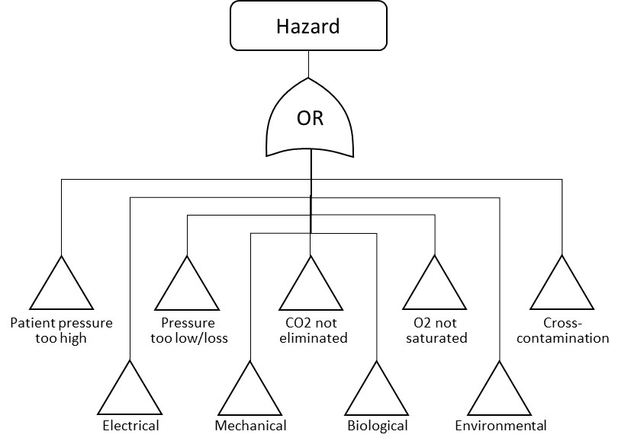

#### Patient pressure too high

Too high a patient pressure can result in worst case result in acute lung damage, or a slower developing volu- and baro-trauma. It can also result in ventilatory insufficiency, by not permitting the lung to wash out CO2.

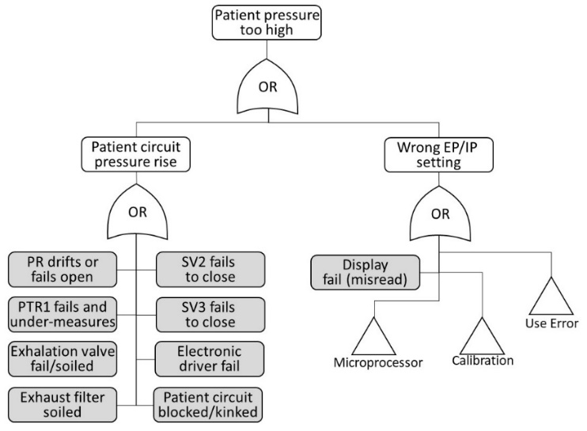

#### Pressure too low

To do.

#### CO2 not eliminated from blood

To do.

#### O2 does not saturate blood

To do.

#### Cross-contamination

To do.

#### Electrical

To do.

#### Mechanical

To do.

#### Biological

To do.

#### Environmental disturbance

The term ‘environmental’ means aspects external to the system subjected to the hazard. This may be external to the device as a whole, or between two or more internal sub-systems. ‘Normal’ EMI means immunity levels presumed in international standards for EMC. ‘Special’ level means in excess of ‘normal’ levels – e.g. in proximity to MRI scanner or other radiation equipment. Normal hazards are usually covered by compliance with 60601-1-2 on EMC, for normal EMI levels. The hazards introduced by special levels are addressed by warnings in the user manual and/or on the device as appropriate.

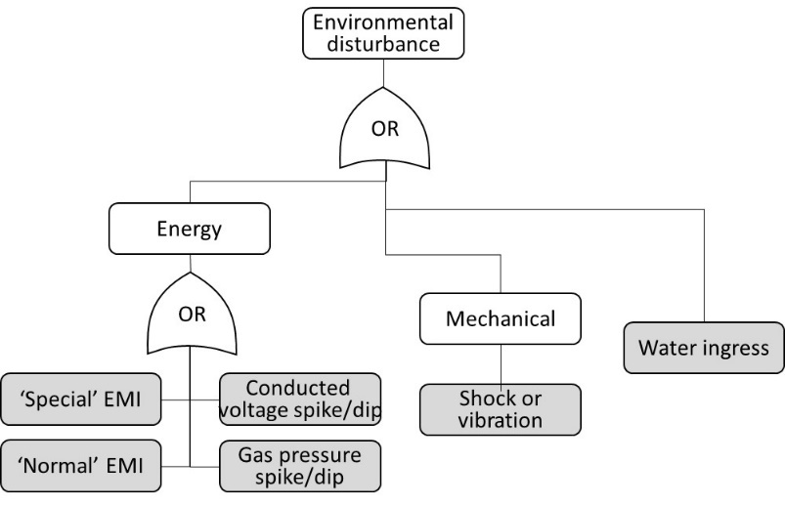

#### Use error

The term ‘use’ extends to any person interacting with the device during clinical application and servicing/calibration. This is foremost clinical and technical servicing personnel, but also other people, incidentally, entering the device environment – such as hospital cleaning personnel, patient parent, siblings and other hospital visitors.

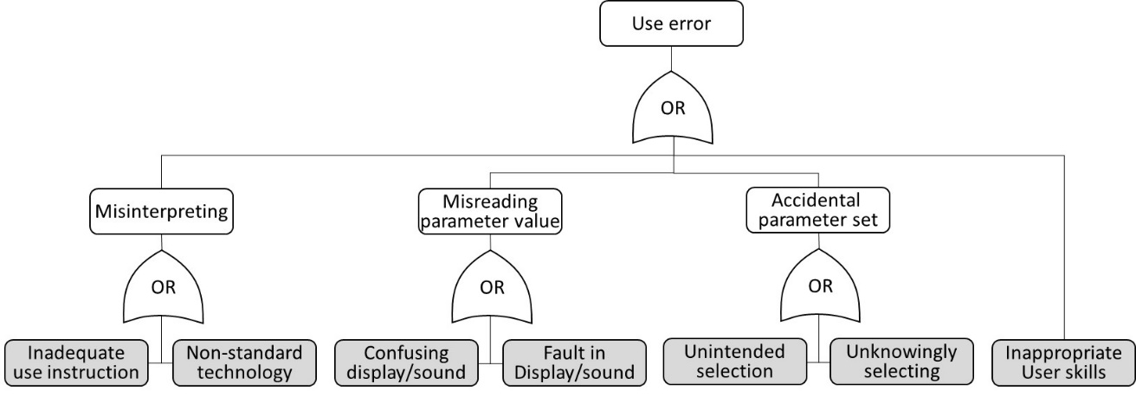

#### Microprocessor

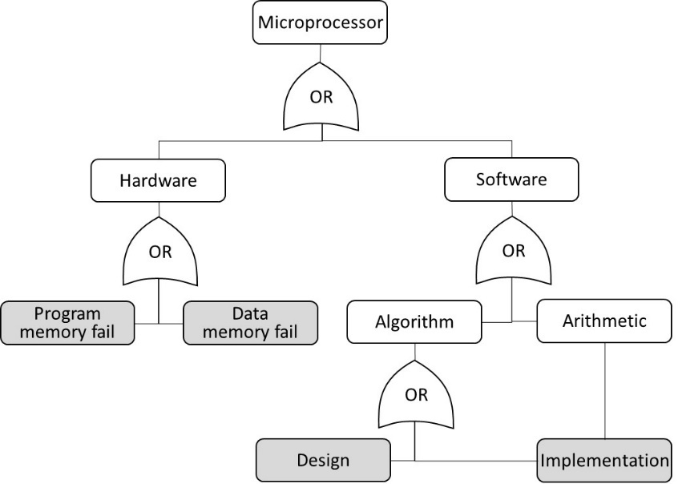

#### Electronics

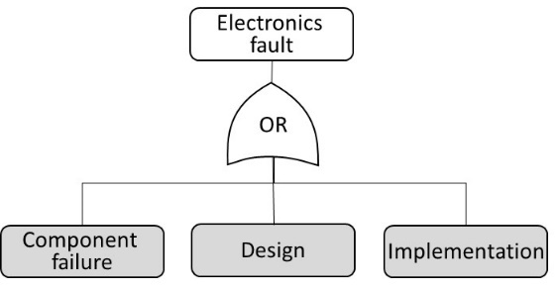

#### Etc…..

To do.

### Risk evaluation

Summarise the initiating causes for each hazard (each greyed box above) and estimates a risk level for each one, assuming no design controls. The worst consequence of a hazard being realized is applied to the rating of all the associated initiating causes for the particular hazard.

#### Hazard: Patient Pressure is too high

Worst consequence for this hazard: **Catastrophic**

|  |  |  |  |
| --- | --- | --- | --- |
| Initiating cause | Occurrence | Rating | Risk Level |
| PR drifts or fails open | Remote | 7 | Moderate |
| PTR1 fails and under-measures | Remote | 7 | Moderate |
| Exhalation valve fails/soiled | Remote | 7 | Moderate |
| Solenoid valve SV2 fails open | Remote | 7 | Moderate |
| Solenoid valve SV3 fails open | Remote | 7 | Moderate |
| Electronic valve driver fails | Remote | 7 | Moderate |
| Patient circuit blocked/kinked | Remote | 7 | Moderate |
| Display failure | Almost imp. | 20 | Tolerable |

Describe the mitigating design controls and demonstrate how risks are brought to within an acceptable level. (e.g. SV1 mitigates PR, SV2 and SV3 failures; and PTR2 mitigates PTR1; etc…).

#### Hazard: … create section for each the other hazards

Worst consequence for this hazard: **Serious**

## Clinical evaluation

To be performed and described.

Pre-clinical evaluation is a lab test to confirm that the ventilator correctly performs the clinically proven SIMV therapy.

The clinical evaluation is assumed done by consulting several experienced respiratory therapists, and the carefully monitoring of first patients use – having alternative ventilators on standby.

## Usability evaluation

To be performed and described. Assumed done by consulting several experienced respiratory therapists.

## Accelerated life-cycle and environmental testing

Drop and heat-cycle tests should be performed prior to releasing the design for production.

Component level life-cycle performance must be declared by their manufacturers. System level accelerated testing can commence immediately a functional design is made and it can continue in parallel to ramping up production. Quantify and assure acceptance of the risk that rework might be required. Such risk must be taken for the 6-week supply time to be met.

## Biocompatibility evaluation

To be performed and described. Assumed done as a desk exercise. Rely on component supplier declarations.

# Supporting concepts

## Low tech gas blender

If the concept ventilator must have an integrated Air-Oxygen blender, then below is a well-known low-tech, non-electric principle. The 3 pressure regulators (1 pilot and 2 pilot operated) equalises the Air and Oxygen lines, allowing for a mechanical proportional divider. The divider is a screw spindle, which gradually opens for one gas while simultaneously gradually closes the other gas. The screw thread is dimensioned to create the full 21% to 100% oxygen concentration range in ¾ turn of the spindle.

The screw and cone-shaped spindle housing are precision machined parts. When the machining and manufacturing capability exists, the non-return valves and pressure regulators could potentially be integrated into the machines housing part – to form a single blender block.

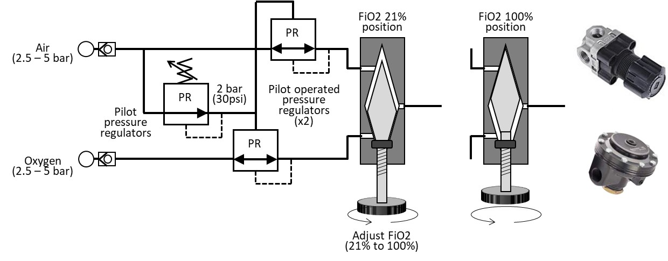

The blender can be integrated into the ventilator, or it could be mounted externally as an optional extra to the ventilator base design.

## Exhaled gas (heat) disinfection device

Exhaled gas from the ventilator valve will contain concentrations of bacterial and viral pathogens, which places healthcare staff and other patients at risk of cross-contamination.

Bacteria and viruses are intolerant to temperatures above 60 deg.C. Sufficient thermal energy is required to heat the bacteria or virus to this temperature – i.e. a higher than 60 deg.C temperature is required when the heat exposure time is short.

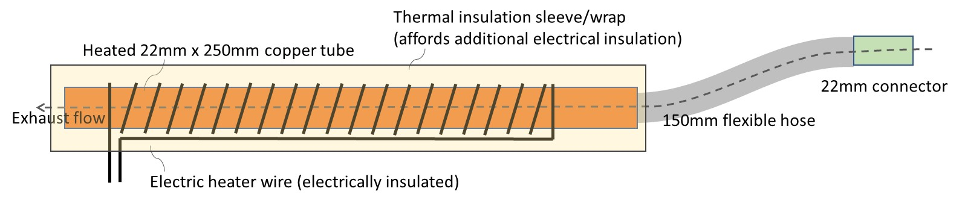

A proposed ventilator exhaust gas disinfector concept consists of a copper tube that is heated to 80+ deg.C (to be validated). Air has low specific heat capacity and quickly reaches this temperature when flowing through the tube. Small viruses also easily reach this temperature. Larger bacteria and viruses suspended in water droplets might take longer to reach temperature, but it can be assumed that a proportion will perish or be sufficiently ‘wounded’ to incapacitate them for self-destruction.

The gas disinfection device can be fitted to any ventilator’s 22mm exhalation port, including in series with a bacterial filter. It must be fitted outside the patient environment! – meaning it must not be within reach of anyone touching the patient, who can be frail and sensitive to electrical safety.

## Humidification

Dry gas from compressed supply lines must be conditions, prior to reaching the lung. The endotracheal tube bypasses the upper airway, which usually raised the temperature and moisture contents. Without this the gas dries the mucous tissue, impairing the lung function and increases the risk of infections. Some clinicians have suggested that they achieve best outcomes for Covid-19 patients when the fresh gas carries maximum humidity. The statement remains to be validated, but it does not disagree with general ICU practices.

The optimum gas is 37 deg.C and 100%RH at the time it reaches the patient interface. At this temperature, 100%RH equates to 44g of water per cubic meter of gas. When the gas temperature if 34 deg.C it carries maximum 33g/m3 water. At 20 deg.C it can carry only 17g/m3.

The HME device performs a cross-over exchange of heat and moisture, from the exhaled gas into the fresh gas. The exchange is satisfactory for the needs of most patients. There are however more effective humidification devices available, for the most compromised patients. The emergency ventilator proposed in this document is compatible with such humidifiers. But, just as for the ventilators, these humidifiers are currently in short supply.

There is merit in developing an easy manufacturable humidifier that can condition patient gas to 37 deg.C 100%RH. The challenge is to carry the gas to the patient interface without losing temperature – because the water will ‘rainout’ of the saturated gas and collect inside the patient circuit. Rainout water can eventually obstruct the circuit and prevent ventilation. If 100%RH gas in excess of the patient temperature (>37 deg.C, unless patient has a fever) enters into the lung, then the rainout occurs inside the lung (in effect drowning the patient). Such build-up of water usually takes hours to occur and will become obvious before it is hazardous. It would be preferable that the device could be turned down little, if excess moisture is observed in the circuit or the patient.

As a safety precaution, inhaled gas temperature should never exceed 43 deg.C (or 55 deg.C for a single breath). Design guidance is found in standard EN8185:2007 on Respiratory tract humidifiers for medical use – Particular requirements for respiratory humidification systems.